Dev Shield Version 0.00 Errata
- No capacitors! (Seems to work fine, though.) See my Eagle file in Github for what should go where if you want to solder these yourself.
- The RX and TX LEDs are designed as if their inputs were active high, but actually the inputs are active low. Thus, they are invisible during data transmission.
- Relay connector is mislabeled. It should be:
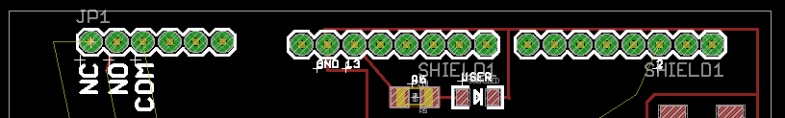
Pull Arduino pin 2 high and it relay will connect COM to NC, make clicking sound, etc.
- TMP102 – Haven’t determined yet if it’s working. It also may be installed upside down – can’t see markings.
- “R9” is the solder jumper we talked about for reset.

